Week 1 - Task 1
SOC2-Lite Governance Framework – MVP Scope
This document defines basic safety and control rules for AI agents in Extream.AI to ensure secure and responsible operation under MVP scope.

Governance Objectives
- Make AI work safely
- Stop harmful actions
- Track everything AI does
- Classify risky actions
- Ask human approval for risky actions

Governance Checkpoints
1. Prompt Validation
Every user prompt must be checked before AI executes it. Unsafe or restricted prompts will be blocked.
2. Agent Decision Logging
Every AI decision and action must be recorded with timestamp, user ID, and risk level.
3. Escalation Approval
High and Critical risk actions require human approval before execution.
4. Action Traceability
Every action must be traceable from the original prompt to final execution.

Risk Classification
Low → Safe actions (text generation)
Medium → Small impact (sending email)
High → Sensitive data or money
Critical →System changes or data deletion

Workflow

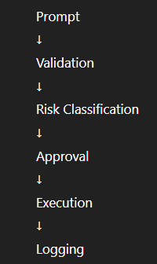

Approval Boundaries
Human approval required when:
- Risk is High or Critical
- Money involved
- Sensitive data accessed
- System changes happen

